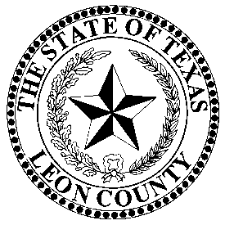 | LEON COUNTY ELECTION’S OFFICE
 | Donna Kominczak, Election Administrator
 | P.O. Box 1239, 155 N Cass Street, Centerville, Texas 75833 903/536-4469 903/536-1773-FAX

May 3rd, 2025, City/School Election School

We will be conducting a formal Election School for the upcoming May 3rd, 2025, City/School Election on Wednesday, April 16th at 1:00 P.M. Leon County Annex I 3rd floor Grand Room 113 West Main Street Centerville, Texas 75833.

Donna Kominczak
Leon County Elections Administrator,
(903) 536-4469 Office
Donna.kominczak@co.leon.tx.us

